To: New York Department of Environmental Conservation
From: Parin Shaik
DATE: 16 December 2025
SUBJECT: INVASIVE POTENTIAL OF CRABS URGENT!!!

Problem Statement
Once the crabs begin spreading from Montauk, NY, toward Southampton, their invasive potential becomes clear. Establishment may take several years, but once settled, the population crosses the management threshold within months, leaving little opportunity for intervention. Their expansion toward NYC unfolds more gradually, yet still carries substantial uncertainty in how rapidly and heavily populations will grow.

Analysis & Results
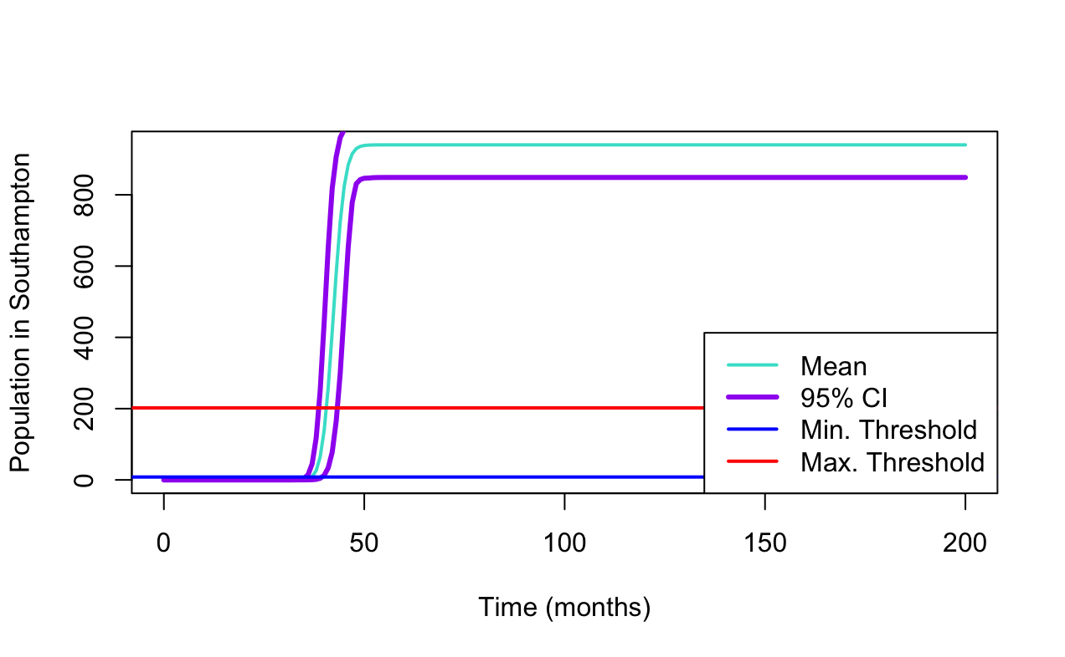
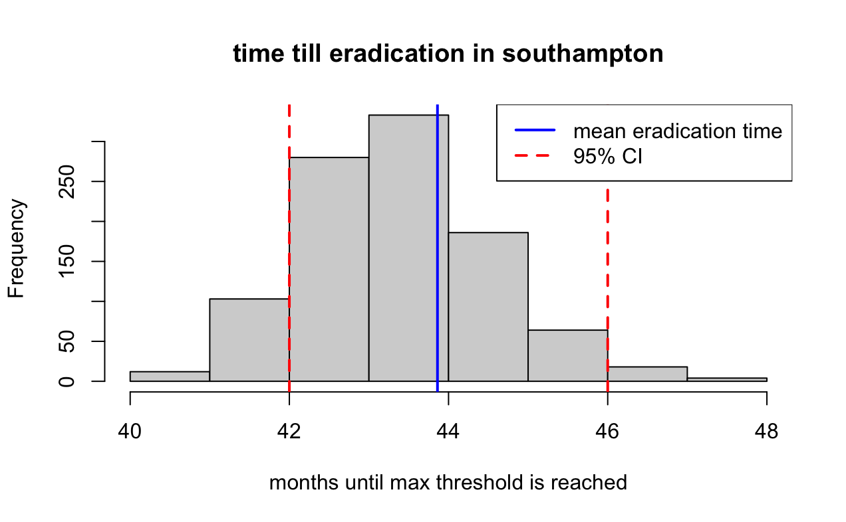
The time-series plot above shows that crabs reach the establishment threshold in Southampton at an average of approx. 40 months (95% CI: 38-43 months) across 1000 simulations. After establishment, the densities increase rapidly. The eradication threshold is crossed at approx. 44 months–as confirmed in the 95% confidence interval: [42, 46 months].

This gives a very narrow scope of only 3-4 months between the first establishment and the point at which eradication is no longer possible (the differences between the two intervals). The histogram of eradication times in the second figure above also confirms that this transition happens quickly and consistently across the simulations.
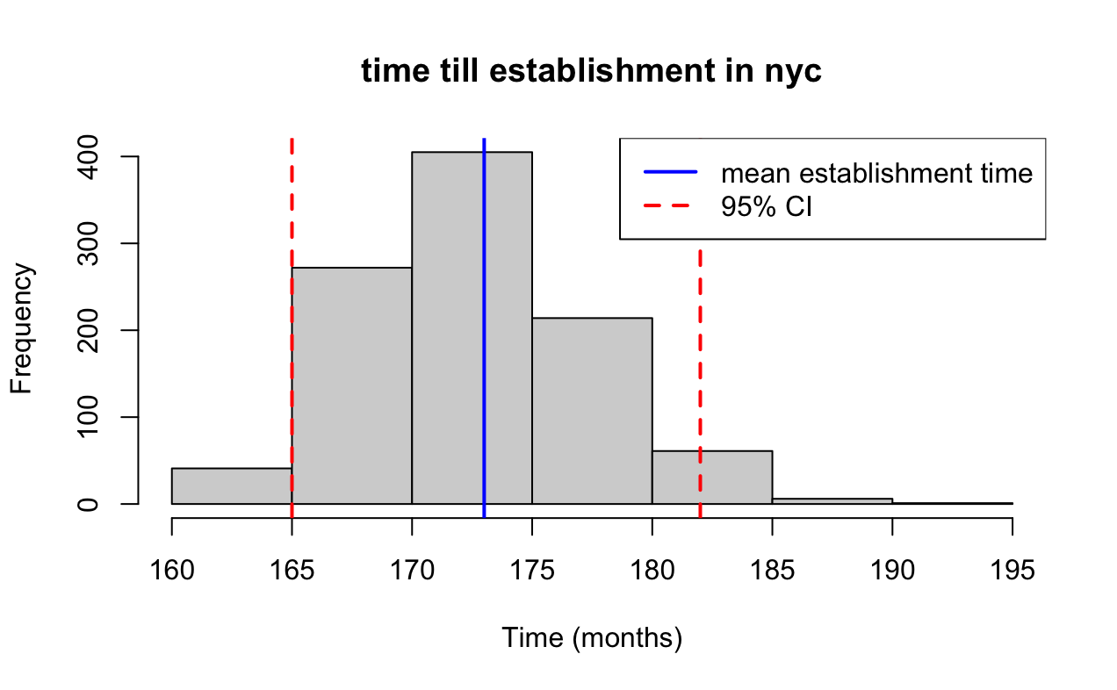
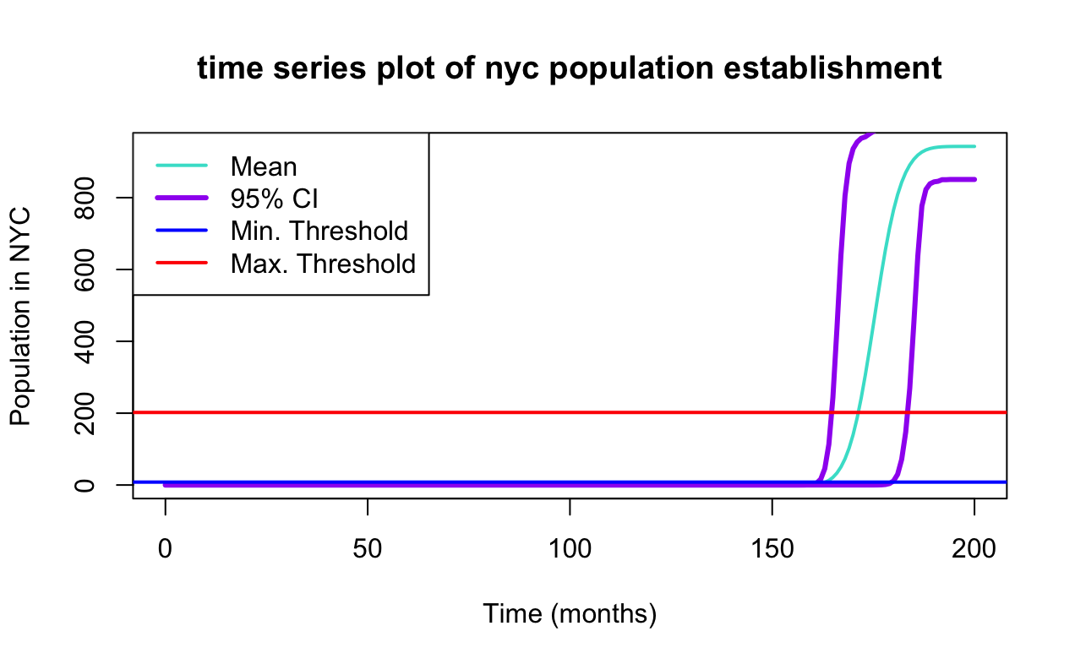

The second model predicts that crabs reach NYC much later, at an average of approx. 173 months (~14.42 years). The 95% uncertainty interval is wider [165-182 months], reflecting greater variability over longer distances. Although the population’s arrival occurs comparatively later than in Southampton, the broader confidence interval indicates substantial uncertainty in the exact timing.

Conclusions & Recommendations
Overall, it is clear that the crab population has a strong potential to become an invasive species in Southampton and in New York City, although moreso in the former than the latter. Once the population establishes itself in Southampton, growth accelerates rapidly logistically, surpassing eradication thresholds within a matter of months. In contrast, the spread toward NYC takes longer to occur, but with substantial uncertainty, indicating that early detection and preventative measures remain essential for mitigation.

